AIM / OBJECTIVE: Virtual Mouse

Libraries used:

# • OpenCV • Media pipe • NumPy • AutoPy

CODE :

Hand Tracking Module:

|  |
| --- |
| import cv2 import mediapipe as mp import time import math import numpy as np    class handDetector: def __init__( self, mode=False, maxHands=2, modelComplexity=1, detectionCon=0.5, trackCon=0.5  ): self.mode = mode self.maxHands = maxHands self.modelComplex = modelComplexity self.detectionCon = detectionCon self.trackCon = trackCon  self.mpHands = mp.solutions.hands self.hands = self.mpHands.Hands( self.mode, self.maxHands, self.modelComplex, self.detectionCon, self.trackCon,  )  self.mpDraw = mp.solutions.drawing_utils self.tipIds = [4, 8, 12, 16, 20]  def findHands(self, img, draw=True):  imgRGB = cv2.cvtColor(img, cv2.COLOR_BGR2RGB) |

|  |
| --- |
| self.results = self.hands.process(imgRGB)  # print(results.multi_hand_landmarks)  if self.results.multi_hand_landmarks:  for handLms in self.results.multi_hand_landmarks: if draw:  self.mpDraw.draw_landmarks( img, handLms, self.mpHands.HAND_CONNECTIONS )  return img  def findPosition(self, img, handNo=0, draw=True):  xList = [] yList = [] bbox = [] self.lmList = [] if self.results.multi_hand_landmarks:  myHand = self.results.multi_hand_landmarks[handNo] for id, lm in enumerate(myHand.landmark):  # print(id, lm) h, w, c = img.shape cx, cy = int(lm.x * w), int(lm.y * h) xList.append(cx) yList.append(cy) # print(id, cx, cy) self.lmList.append([id, cx, cy]) if draw:  cv2.circle(img, (cx, cy), 5, (255, 0, 255), cv2.FILLED)  xmin, xmax = min(xList), max(xList) ymin, ymax = min(yList), max(yList) bbox = xmin, ymin, xmax, ymax  if draw:  cv2.rectangle(  img, (xmin - 20, ymin - 20), (xmax + 20, ymax + 20), (0, 255, 0),  2  )    return self.lmList, bbox  def fingersUp(self):  fingers = [] # Thumb if self.lmList[self.tipIds[0]][1] > self.lmList[self.tipIds[0] - 1][1]:  fingers.append(1) else:  fingers.append(0)    # Fingers for id in range(1, 5): |
| if self.lmList[self.tipIds[id]][2] < self.lmList[self.tipIds[id] - 2][2]:  fingers.append(1) else:  fingers.append(0)    # totalFingers = fingers.count(1)  return fingers  def findDistance(self, p1, p2, img, draw=True, r=15, t=3):  x1, y1 = self.lmList[p1][1:] x2, y2 = self.lmList[p2][1:] cx, cy = (x1 + x2) // 2, (y1 + y2) // 2  if draw:  cv2.line(img, (x1, y1), (x2, y2), (255, 0, 255), t) cv2.circle(img, (x1, y1), r, (255, 0, 255), cv2.FILLED) cv2.circle(img, (x2, y2), r, (255, 0, 255), cv2.FILLED) cv2.circle(img, (cx, cy), r, (0, 0, 255), cv2.FILLED) length = math.hypot(x2 - x1, y2 - y1)  return length, img, [x1, y1, x2, y2, cx, cy]    def main(): pTime = 0 cTime = 0 cap = cv2.VideoCapture(0) detector = handDetector() while True:  success, img = cap.read() img = detector.findHands(img) lmList, bbox = detector.findPosition(img) if len(lmList) != 0: print(lmList[4])  cTime = time.time() fps = 1 / (cTime - pTime) pTime = cTime  cv2.putText(  img, str(int(fps)), (10, 70), cv2.FONT_HERSHEY_PLAIN, 3, (255, 0, 255), 3  )  cv2.imshow("Image", img) cv2.waitKey(1)    if __name__ == "__main__":  main() |

Project(OpenCV):

import cv2

|  |
| --- |
| import numpy as np import HandTrackingModule as htm import time import autopy    ########################## wCam, hCam = 640, 480 frameR = 100 # Frame Reduction smoothening = 7  #########################  pTime = 0 plocX, plocY = 0, 0 clocX, clocY = 0, 0  cap = cv2.VideoCapture(0) cap.set(3, wCam) cap.set(4, hCam)  detector = htm.handDetector(maxHands=1) wScr, hScr = autopy.screen.size()  # print(wScr, hScr)  while True:  # 1. Find hand Landmarks success, img = cap.read() img = detector.findHands(img) lmList, bbox = detector.findPosition(img) # 2. Get the tip of the index and middle fingers if len(lmList) != 0:  x1, y1 = lmList[8][1:] x2, y2 = lmList[12][1:] # print(x1, y1, x2, y2)    # 3. Check which fingers are up fingers = detector.fingersUp()  # print(fingers) cv2.rectangle(  img, (frameR, frameR), (wCam - frameR, hCam - frameR), (255, 0, 255), 2 )  # 4. Only Index Finger : Moving Mode if fingers[1] == 1 and fingers[2] == 0:  # 5. Convert Coordinates x3 = np.interp(x1, (frameR, wCam - frameR), (0, wScr)) y3 = np.interp(y1, (frameR, hCam - frameR), (0, hScr))  # 6. Smoothen Values  clocX = plocX + (x3 - plocX) / smoothening clocY = plocY + (y3 - plocY) / smoothening    # 7. Move Mouse  autopy.mouse.move(wScr - clocX, clocY)  cv2.circle(img, (x1, y1), 15, (255, 0, 255), cv2.FILLED) plocX, plocY = clocX, clocY |
| # 8. Both Index and middle fingers are up : Clicking Mode if fingers[1] == 1 and fingers[2] == 1: # 9. Find distance between fingers length, img, lineInfo = detector.findDistance(8, 12, img) print(length)  # 10. Click mouse if distance short if length < 40:  cv2.circle(img, (lineInfo[4], lineInfo[5]), 15, (0, 255, 0), cv2.FILLED) autopy.mouse.click()  # 11. Frame Rate cTime = time.time() fps = 1 / (cTime - pTime) pTime = cTime cv2.putText(img, str(int(fps)), (20, 50), cv2.FONT_HERSHEY_PLAIN, 3, (255, 0, 0),  3)  # 12. Display  cv2.imshow("Image", img) cv2.waitKey(1) |

Output:

# Hand key points for OpenCV

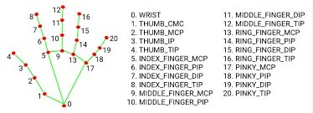

# Display Window

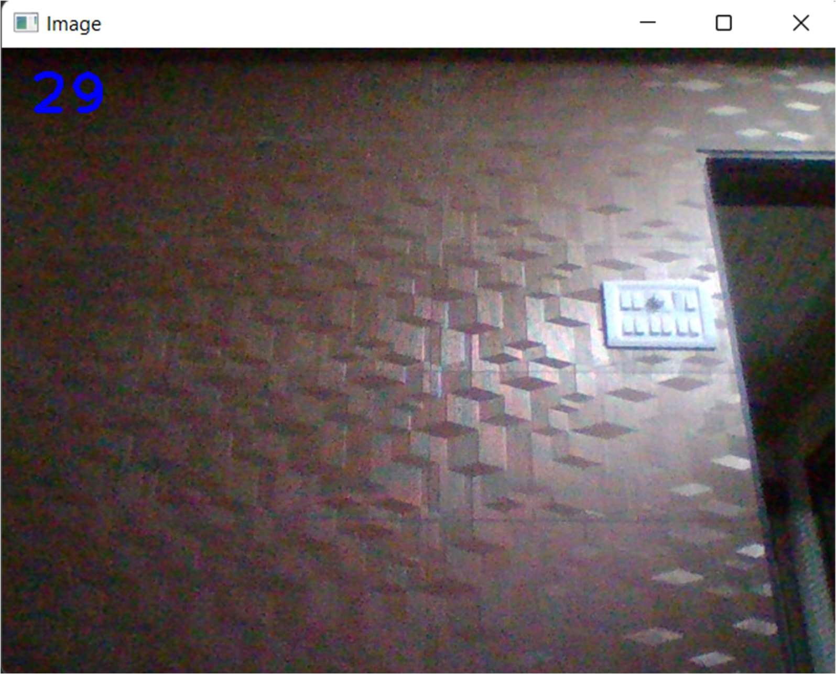

# Cursor tracking

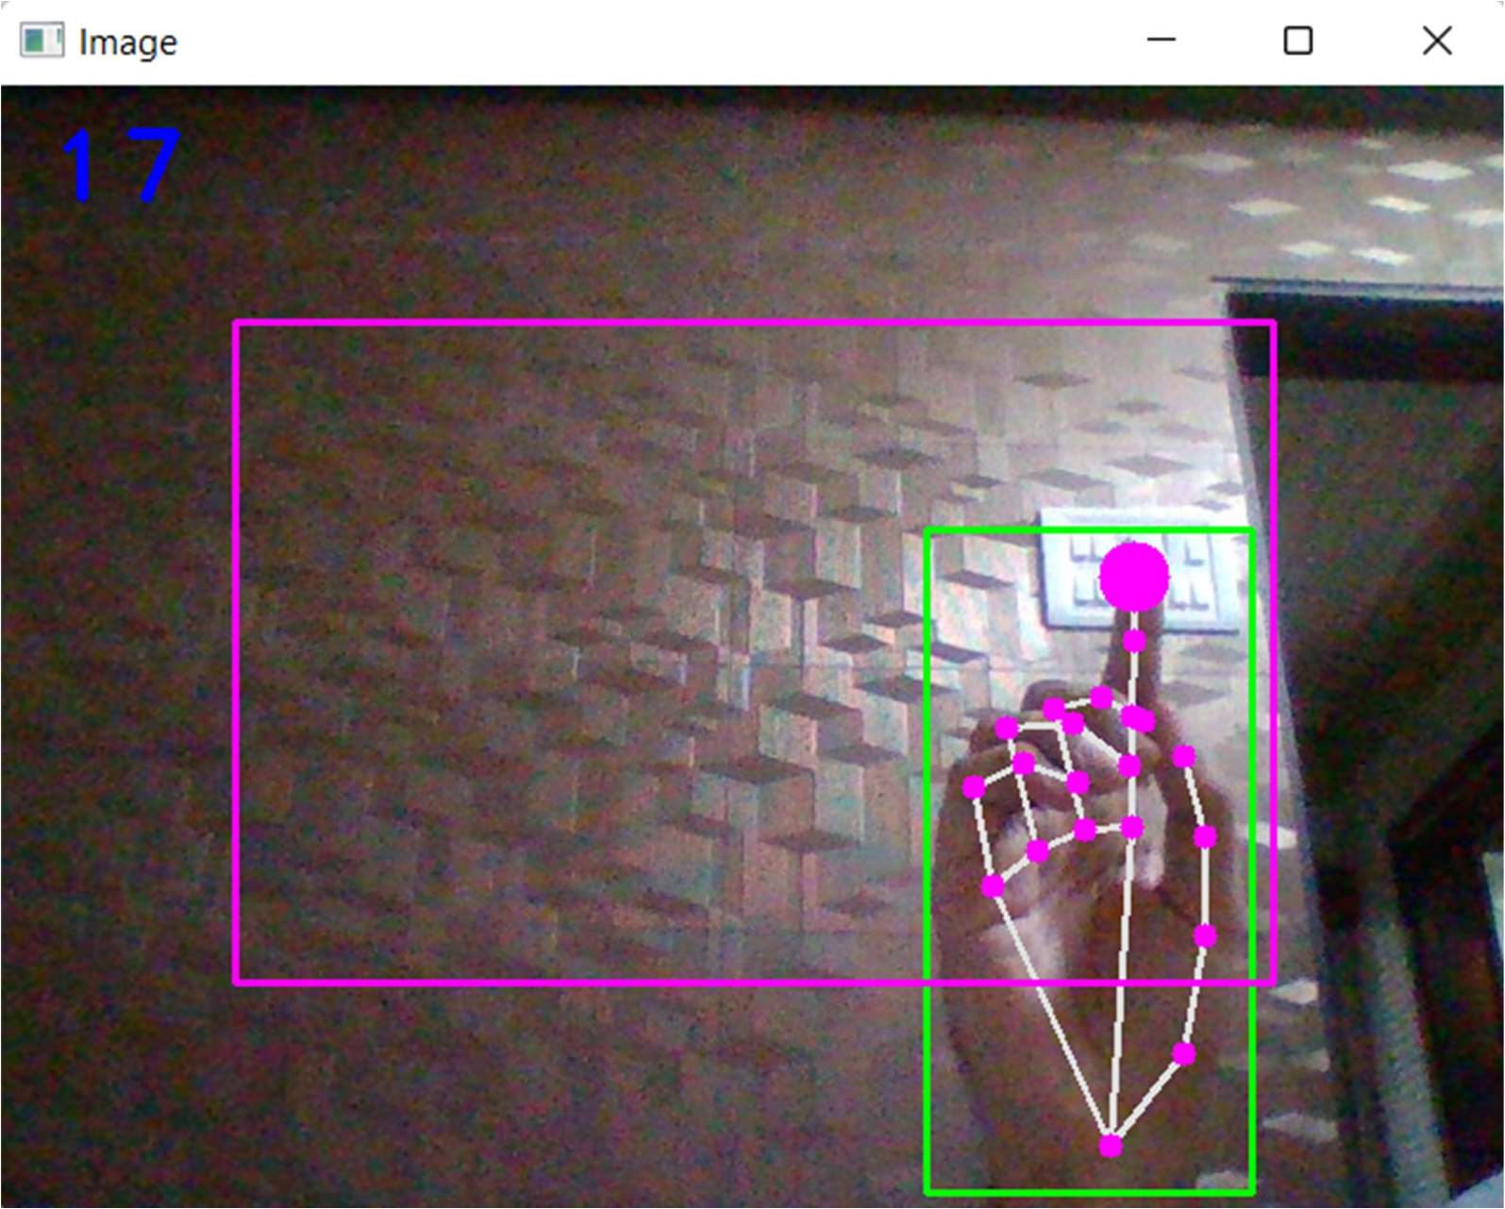

# Clicking mode

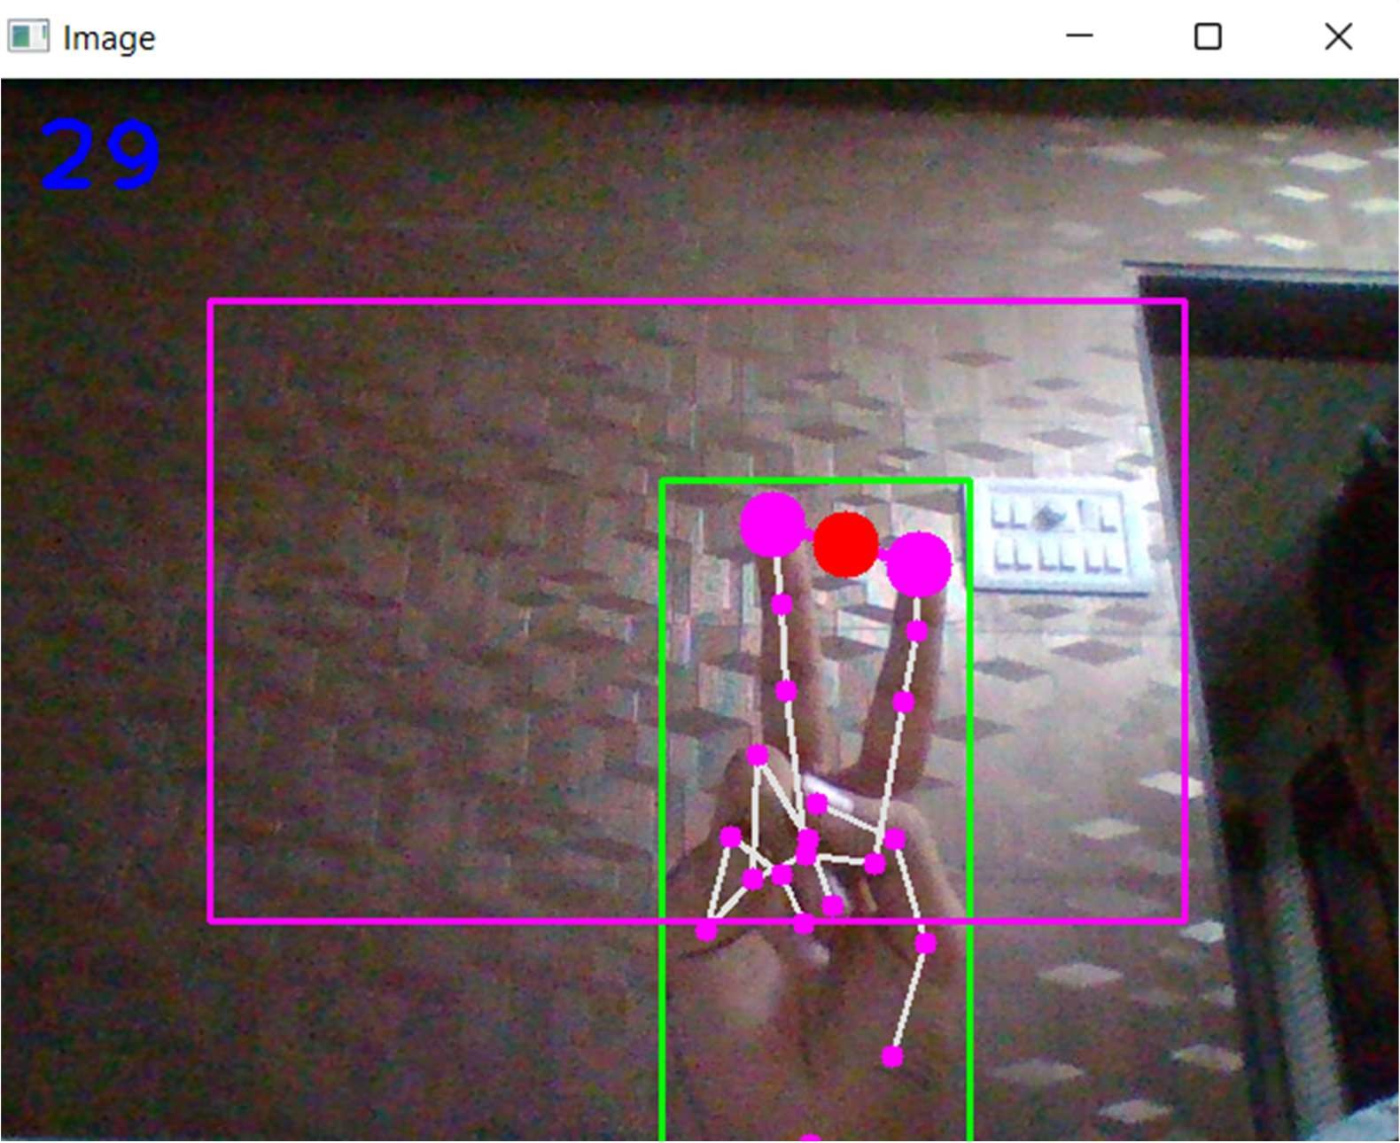

# It doesn’t detect more than one hand

